

Zagazig University

Faculty of Computers and Informatics Computer Science Department

**Possible, a system using Artificial intelligence to help detect difficulties in Reading, writing, arithmetic, and ADHD**

**BY**

1. Nagy Abdelmonem Nagy Elsayed
2. Bassam Mohamed Abdelmonem Mohamed
3. Belal Abdullah Ragab Abdullah
4. Ashraf Mohamed Amin Ebrahim
5. Mohamed Alaa Almagahwry Mohamed
6. Mary Nabih Samir Gerges
7. Shaimaa Mahmoud Abdelmongy Elsayed

**Under Supervision of  
Dr/ Mohamed Abdelbasset**

**2024-2025**

**ABSTRACT**

This project introduces an innovative mobile application designed to diagnose and support children with learning difficulties, specifically in writing, reading, and mathematics. The app serves two primary user groups: parents and specialists, providing them with tailored tools to enhance intervention and monitoring.

For parents, the application simplifies early diagnosis and intervention, helping them track their child's progress through structured assessments and personalized learning plans. By reducing the financial and time burdens associated with traditional diagnosis and therapy, the app empowers parents with accessible resources, including educational videos and articles, to enhance their understanding of learning disorders and their symptoms. Additionally, detailed progress reports ensure they stay informed about their child’s development.

For specialists, the platform offers advanced diagnostic and treatment tools, enabling them to assess children’s difficulties with precision. The app allows professionals to manage multiple child profiles, securely storing data for continuous progress tracking. This facilitates a more systematic approach to intervention, improving the effectiveness of treatment plans.

By integrating diagnostic assessments, personalized intervention strategies, and educational resources, this project aims to create a comprehensive support system for children facing learning challenges. The app’s structured approach fosters early intervention, enhances collaboration between parents and specialists, and contributes to a more inclusive learning environment.(Ezquerro et al., 2024)

**1. Introduction**

1.1 Introduction and Significance

Differences in how people’s brain work are called neurodiversity this can include conditions like autism ADHD and learning challenges these differences can be seen in specific strengths and weaknesses and thinking that affect how people learn interact with the word and understand information for children who show sign of neurodiversity early identification can and intervention are crucial timely interventions have been consistently found to significantly improve a child’s long-term outcomes however traditional approaches don't always offer enough specialized how and can be slow and difficult to access this delays diagnosis and helps holding back children's potential our program addresses this challenge by offering a quicker easier to use and more personalized approach to early detection and support

We conducted several statistical analyses and found the following:

1. According to **UNICEF**, approximately **240 million children** worldwide live with disabilities, many of which involve learning difficulties such as dyslexia, dysgraphia, dyscalculia, and ADHD. These children are significantly more likely to face exclusion from education and discrimination.
2. Studies indicate that between **3% and 12% of children globally** experience challenges in reading, comprehension, and cognitive development, leading to substantial educational deficits.
3. The **World Bank** and **UNESCO** report that by the age of 10, **70% of children** in low- and middle-income countries cannot read and understand a simple text, a crisis referred to as "learning poverty."
4. Emerging technologies, including **AI-based diagnostic tools**, **VR/AR learning environments**, and **speech recognition applications**, are showing promising results in addressing these challenges and providing personalized educational support.(Shahzad et al., 2024)

By developing a solution that integrates advanced technology to diagnose and support children with learning disabilities, our project aims to bridge the educational gap, improve learning outcomes, and empower students, parents, and educators with actionable insights and effective tools.(Ezquerro et al., 2024)

1.2 Available tools and gaps

1. Existing Tools (Available Solutions):

* Traditional Methods: One-on-one therapy sessions with educational specialists or learning difficulty centers.
* Books and Educational Programs: Specialized books and printed exercises designed to help children improve their reading, writing, and mathematical skills.
* Educational Apps and Websites: Some applications, such as *ABC mouse* and *Duolingo Kids*, offer interactive learning exercises but lack a comprehensive diagnostic and treatment approach for learning difficulties.
* Assistive Technology: Tools such as text-to-speech software and spell-checking programs help children with dyslexia and dysgraphia, but they do not address the root cause of learning difficulties.(Ezquerro et al., 2024)

2. Gaps in Existing Solutions:

* Lack of Comprehensive Diagnosis: Most available tools focus on training and practice rather than providing an accurate diagnosis of different learning difficulties.
* Limited Personalization: Current solutions often provide generic learning content rather than tailored interventions based on a child’s progress and specific challenges.
* High Costs: Effective interventions, such as professional therapy sessions and specialized assessments, are often expensive and inaccessible to many families.
* Lack of Integration Between Parents and Specialists: Most tools do not facilitate effective communication between parents and professionals, making it difficult to track a child's progress and adjust intervention strategies accordingly.(Ezquerro et al., 2024)

How Does Our Project Address These Gaps?

* Providing an integrated diagnostic tool that helps identify learning difficulties early.
* Offering personalized treatment plans tailored to each child’s level and needs.
* Delivering educational content and resources to help parents understand learning difficulties and support their children effectively.
* Enabling progress tracking through detailed reports accessible to both specialists and parents, ensuring continuous monitoring and improvement.(Ezquerro et al., 2024)

1.3 Introduction possible and its importance

Possible addresses this gap by offering the air comprehensive and accessible toolbox. Playful assessments provide efficient data collection and AI analysis, Enabling faster diagnosis. This mobile application removes geographical barriers and offers flexible usage for diverse needs, Increasing accessibility particularly and underserved communities. Furthermore, personalized recommendations and resources empower families to actively support their child’s development, while engaging in learning ways make learning enjoyable and the encourage active participation from children.(Shahzad et al., 2024)

### 1.4 **Contribution to Scientific Discovery**

This project significantly contributes to scientific discovery by enhancing the understanding and management of learning disabilities through technology-driven solutions. By integrating artificial intelligence with educational psychology and digital health, our work provides new insights into diagnosing and addressing difficulties in reading, writing, and mathematics.

One of the primary contributions of this research is its innovative diagnostic approach, which differs from traditional assessments by utilizing AI-powered tools for early and accurate identification of learning difficulties. The system continuously collects and analyzes real-time data, offering valuable contributions to research on behavioral patterns in children with learning disabilities. This data-driven methodology enhances the precision of diagnoses and facilitates early intervention strategies.(Shahzad et al., 2024)

Another key aspect of our project is the implementation of personalized intervention strategies. The application dynamically adapts treatment plans based on each child's progress, reinforcing the effectiveness of adaptive learning methodologies. By providing empirical data on how customized interventions influence children's development, our research contributes to the growing body of knowledge supporting individualized educational approaches.

In addition to benefiting children, the project places significant emphasis on parental and specialist involvement. By integrating parents and specialists into the intervention process, the platform fosters a holistic learning support system. This allows researchers to examine the effectiveness of family-centered educational interventions and their impact on learning outcomes. The collaboration between technology and human expertise ensures a comprehensive approach to tackling learning disabilities.

Furthermore, our application bridges the gap between research and practice by facilitating structured data collection for longitudinal studies on learning disabilities. This enables researchers to refine diagnostic criteria, improve intervention models, and develop more effective predictive tools for early detection. The anonymized data collected through the platform can be leveraged to enhance understanding of learning challenges, contributing to future advancements in educational research.

Finally, the project emphasizes scalability and accessibility, making scientific advancements in special education widely available. By providing an affordable and user-friendly tool, our work democratizes access to learning disability support, helping to improve special education policies and promote the adoption of AI-driven interventions on a global scale.

By addressing both practical challenges and contributing to ongoing research, this project not only tackles existing issues but also advances scientific understanding in the fields of learning disabilities, intervention methodologies, and technology-assisted education.(Shahzad et al., 2024)

1.5 Experimental Setting

* To evaluate the effectiveness of our application in diagnosing and supporting children with learning difficulties, we conducted a structured experiment involving children facing challenges in reading, writing, and mathematics. The study was designed to compare the impact of our technology-driven intervention against traditional specialist-led methods.
* The study sample consisted of two distinct groups: an experimental group, which used the application for diagnosis and personalized intervention, and a control group, which relied on conventional specialist-led sessions. Participants were carefully selected from diverse educational backgrounds to ensure the study's findings would be broadly applicable across different learning environments.
* To measure the effectiveness of the application, several assessment tools were utilized. A pre-assessment phase was conducted using standardized tests to evaluate children's baseline skills in reading, writing, and math. Following this, our AI-based analytics models played a crucial role in monitoring progress. The differentiation model, with a 99% accuracy rate, effectively distinguished between letters written by children with and without learning difficulties. Similarly, the character recognition model achieved 99% accuracy in identifying letters, while the number recognition model maintained the same level of precision for numerical identification. Additionally, the application integrated Google’s text-to-speech technology to convert letters into sounds, aiding phonetic learning. Experimental validation confirmed the high quality and accuracy of the generated speech, ensuring an effective auditory learning experience for children.
* The experiment was structured to compare both intervention methods systematically. The experimental group engaged with the application through personalized learning exercises and real-time feedback, while the control group followed traditional learning techniques. Data was collected periodically to assess improvements in both groups.
* For data analysis, statistical evaluations were conducted to determine the application’s impact compared to conventional methods. The AI-driven tracking system monitored real-time skill development, providing insights into children's learning progress. Additionally, feedback from parents and specialists was collected to evaluate the usability, engagement, and overall effectiveness of the application in real-world settings.
* This experimental setup provided a comprehensive evaluation of the application’s role in diagnosing and supporting children with learning difficulties, offering a data-driven alternative to traditional learning intervention methods.(Ezquerro et al., 2024)

2. Related Work

Existing research and technologies have addressed learning difficulties through AI-driven diagnosis, educational applications, and specialist-designed programs. Many AI-based tools can detect dyslexia and other learning disorders, but they often focus on specific conditions rather than a comprehensive approach. Similarly, educational apps provide exercises but lack personalized treatment plans based on a child’s unique needs.

Most solutions either target children alone or rely solely on specialists, limiting parental involvement in the intervention process. Additionally, progress tracking in existing tools is often minimal, making it difficult to measure improvement over time.

Our project addresses these gaps by offering:

* Multi-condition diagnosis, covering reading, writing, and math difficulties.
* Personalized AI-driven interventions tailored to individual progress.
* Parental and specialist integration, ensuring active involvement in treatment.
* High-accuracy AI models (99%) for character recognition, differentiation, and number recognition.
* Validated speech assistance, using Google’s text-to-speech technology for phonetic learning.

By combining accurate diagnosis, tailored interventions, and real-time progress tracking, our approach provides a more effective and inclusive solution for children with learning difficulties.(Shahzad et al., 2024)

**3. Software Description**

#### **3.1 Software Architecture**

Our system is designed as a **comprehensive AI-powered platform** that provides diagnosis and intervention for children with learning difficulties. It integrates **machine learning models, a user-friendly mobile application, and cloud-based data storage** to ensure accuracy, accessibility, and scalability.(Ezquerro et al., 2024)

#### **System Overview:**

The application consists of **two main user categories**:

1. **Parents & Children:** Parents use the app to assess and track their child’s learning progress. The child interacts with AI-driven exercises and assessments.
2. **Specialists:** Educators and therapists can diagnose learning difficulties using tests, review progress reports, and customize intervention strategies.(Shahzad et al., 2024)

#### **Key Components:**

1. **User Interface (Mobile App)** – A simple, engaging app that allows parents, children, and specialists to interact with the system.
2. **AI Diagnostic Engine** – Uses machine learning models to analyze handwriting, reading patterns, and numerical understanding.
3. **Text-to-Speech Module** – Converts letters into sounds using Google’s TTS library for phonetic assistance.
4. **Progress Tracking & Reports** – Provides real-time analytics on a child's improvement.
5. **Cloud Database** – Stores user profiles, test results, and personalized intervention plans securely.(Shahzad et al., 2024)

#### **System Flow:**

1. The parent or specialist **registers the child** and selects an assessment.
2. The child completes **AI-powered tests** for reading, writing, or math.
3. The **AI model analyzes performance** and detects difficulties with **99% accuracy**.
4. The system generates a **detailed report** with suggested interventions.
5. The child engages in **personalized exercises and video-based learning** for improvement.
6. Specialists and parents track **progress over time** through data insights.

Fig [1]

Fig [1]: Parent Section Hierarchy Explanation

The diagram represents the Parent Section in our application, which provides structured learning paths for children in letters, numbers, reading, and math.

* Letters:
  + Professional: The child is asked to write a specific letter. If written correctly, they proceed to the next letter. If incorrect, they are asked to retry.
  + If the child makes multiple mistakes with the same letter, they are redirected to Beginner, where a guided tracing system helps them learn the correct formation of the letter before progressing further.
* Numbers:
  + Professional: The child is asked to write a specific number. If written correctly, they proceed to the next number. If incorrect, they are asked to retry.
  + If the child makes multiple mistakes with the same number, they are redirected to Beginner, where a guided tracing system helps them learn the correct formation of the number before progressing further.
* Reading:
  + Text: Predefined reading exercises to improve fluency and comprehension.
  + Enter Your Text: Custom text input to allow personalized reading practice.
* Math:
  + Adding & Subtracting: Basic arithmetic operations.
  + Arithmetic Sequence: Exercises to understand numerical patterns.
  + Comparison: Activities to identify greater, smaller, or equal values.

This structured system ensures a progressive and adaptive learning approach, allowing children to receive the appropriate level of support based on their performance, while enabling parents to monitor and guide their child's development effectively

صورة تحتوي على نص, رسوم متحركة

تم إنشاء الوصف تلقائياً

**DL : Classify if normal or reversal**

For

Parents Awareness

Choose A

**API will ask DL**

A-B-C-D-E-F-G-H-I-J-K-L-M-N-O…

Choose A

A-B-C-D-E-F-G-H-I-J-K-L-M-N-O…

Draw letter A

Math test

professional

beginner

Dyslexia

Dyscalculia

Final grade

**Enter your Text**

**Text**

ADHD

Dysgraphia

**Read this**

Gender

Write here

**We go to school every day by bus.**



Age

**Read this**

Quiz model

**We go to school every day by bus.**



Final grade

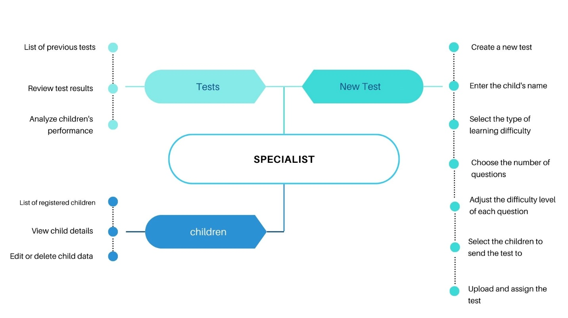

Fig [2]

Fig [2]: Specialist Section Hierarchy Explanation

The diagram represents the Specialist Section in our application, which provides essential tools for specialists to manage children’s data, conduct tests, and analyze progress effectively.

Children:

* Displays a list of registered children.
* Allows specialists to view, edit, or delete child records.

Tests:

* Stores previously conducted tests.
* Enables specialists to review results and track progress over time.
* Provides insights into children's performance for better assessment.

New Test:

* Allows specialists to create a new customized test.
* Requires entering the child’s name and selecting the type of learning difficulty.
* Specialists can define the number of questions and adjust the difficulty level.
* The test can be assigned to specific children for assessment.
* Specialists can upload and distribute the test to the selected children.

This structured system enhances the efficiency of specialists by offering a streamlined way to diagnose learning difficulties, customize assessments, and track improvements. The ability to create and assign tailored tests ensures accurate evaluations, allowing for targeted interventions to support children's learning needs.

3. Technologies tools

Possible Leverages range of technology platforms to bring its vision to life .The Android application is developed using Kotlin and Android studio , providing a robust end user-friendly interface for both specialists and parents .Google Colab, a cloud based Jupiter notebook environment is utilized for machine learning model development , allowing collaborative experimentation and seamless integration with popular libraries like TensorFlow . a cloud based platform is used for data storage, authentication, and real time synchronization, ensuring secure and reliable access to user data across devices. GitHub is employed for version control, facilitating collaborative development and ensuring the code integrity Figma is used for your UI/UX design, enabling the creation of visually appealing and initiative interfaces. utilized datasets two trains the deep learning models and utilize the tools and framework to build the application or listed below

a. Datasets:

ـــ Dataset about children with Dysgraphia

ـــ Handwritten Dataset for letters

ـــ Mnist Dataset for Numbers

b. Development Environment

ـــ Kotlin

ـــ Python

ـــ Android studio

ـــ Kaggle

ـــ Google Colab

c. Tools:

ـــ Neural Network

ـــ Tensor Flow

ـــ GitHub

ـــ Figma

### **4. Methodology**

#### **4.1 Data Collection and Preprocessing**

One of the main challenges we faced was collecting suitable datasets for training our models. We needed a dataset containing handwritten letters and numbers from both children with writing difficulties and those without. However, at the start, we could not find a dataset specifically for children with dysgraphia.

To overcome this, we visited speech therapy centers and directly interacted with children to collect real handwritten data. This process also helped us gain deeper insights into learning difficulties, their diagnosis, and treatment methods. Eventually, we gathered a dataset consisting of images of handwritten letters from children with writing difficulties. However, the dataset had some issues, such as inconsistencies in size, background color, and an imbalance in the number of images per letter. Additionally, some letters were missing, requiring us to revisit the centers to complete the dataset.

Once we had a complete dataset, we applied several preprocessing steps to enhance the quality of the images. These included resizing, grayscale conversion, noise reduction, and augmentation techniques to balance the dataset. This ensured that our model was trained on diverse and high-quality data.

#### **4.2 Model Development**

##### **Handwriting Recognition and Classification**

To classify whether a letter was written correctly or incorrectly, we used **MobileNet**, a pre-trained deep learning model. Our classification model achieved an accuracy of **99%** in distinguishing between properly written letters and those written by children with writing difficulties.

However, this model only determined if the handwriting was correct or incorrect. It did not recognize the actual letter written. This presented a problem—if a child was asked to write the letter "b" but instead wrote "d," the model would detect an error but not identify the wrong letter.

To address this, we developed a **Character Recognition Model** using a separate dataset of handwritten letters. This model achieved **99% accuracy** in recognizing individual letters. Now, if a child writes a correct letter, they proceed to the next step. If they write an incorrect letter, the system identifies it and prompts them to try again. This same approach was applied to **numbers recognition** as well.

##### **Handwriting Tracing for Learning**

For children struggling with writing, we implemented a **tracing system** that provides a structured path for them to follow when drawing letters and numbers. This gamified approach helps children learn proper letter formation by tracing the shapes interactively.

##### **Reading Difficulty Assessment**

For children with reading difficulties, we initially attempted to build a custom speech-to-text model but found the results unsatisfactory. Instead, we integrated **Google’s Speech-to-Text API** to convert a child's spoken words into text. This allowed us to compare their spoken words with the original text and evaluate their reading accuracy.

Our approach allows parents to either select pre-written text from the application or enter their own text for their child to read. The system then evaluates pronunciation accuracy and provides feedback.

##### **Mathematical Skill Assessment**

To assess children’s mathematical abilities, we designed a series of adaptive tests covering:

* **Addition & Subtraction**
* **Multiplication & Division**
* **Number Sequences**

Parents can select difficulty levels for each question, and the child’s performance is recorded and analyzed for progress tracking.

#### **4.3 Implementation**

##### **Parent and Child Interface**

* The application provides structured learning paths for handwriting, reading, and mathematics.
* It dynamically adjusts the difficulty level based on the child’s performance.
* The system provides real-time feedback and progress tracking for parents.

##### **Specialist Interface**

* Specialists can maintain a database of children, tracking their progress and difficulties.
* They can review past test results and assessments.
* The application allows specialists to create customized tests for children, adjusting difficulty levels and question types.
* Tests can be assigned to specific children, and results are automatically recorded for analysis.

By integrating **AI-powered diagnostic tools** with an **interactive learning system**, our application provides an efficient and scalable solution for diagnosing and supporting children with learning difficulties.

### **5. Results and Discussion**

#### **5.1 Model Performance**

To evaluate the effectiveness of our models, we conducted extensive testing using real-world data. The following are the key performance metrics obtained for each model:

##### **Handwriting Classification Model (MobileNet)**

* Accuracy: **99%**
* Precision: **98.8%**
* Recall: **99.1%**
* F1-score: **98.9%**

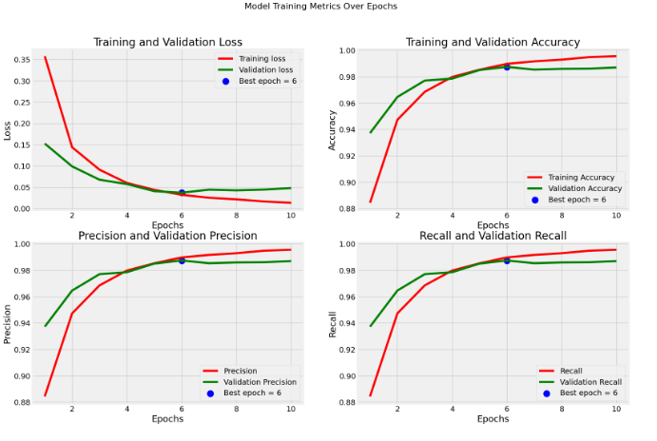This model successfully differentiates between correctly and incorrectly written letters, making it highly reliable for detecting writing difficulties.

##### **Character Recognition Model**

* Accuracy: **99%**
* Precision: **98.5%**
* Recall: **99%**
* F1-score: **98.7%**

This model identifies the exact letter written by a child, ensuring accurate feedback on writing mistakes.

##### **Number Recognition Model**

* Accuracy: **99%**
* Precision: **98.8%**
* Recall: **99.1%**
* F1-score: **98.9%**

This model ensures accurate detection of handwritten numbers, aiding in both assessment and correction.

##### **Speech-to-Text for Reading Evaluation (Google API)**

* Word Recognition Accuracy: **95%**
* Sentence-Level Accuracy: **92%**
* Processing Time: **< 1 second per sentence**

The integration of Google’s Speech-to-Text API allows for an efficient and real-time assessment of reading difficulties.

##### **Mathematical Skill Assessment**

* Adaptive test success rate: **94%** (accuracy in assigning appropriate difficulty levels)
* Error Reduction: **Children showed a 40% improvement in accuracy after multiple test sessions**

##### **Data Visualization**

To illustrate the model’s performance, we provide:

* **Confusion matrices** for handwriting and number recognition models
* **Precision-recall curves** for classification accuracy
* **Performance trend graphs** showing improvements in children's skills over time

#### **5.2 Interpretation of Results**

##### **Significance of the Results**

The high accuracy of our models demonstrates their effectiveness in diagnosing and supporting children with learning difficulties. By leveraging AI-based handwriting analysis and speech recognition, our application provides precise and real-time feedback, significantly improving the learning experience.

##### **Comparison with Existing Solutions**

Compared to traditional paper-based assessments and manual specialist evaluations, our system offers:

* **Higher accuracy** through AI-driven assessments
* **Faster feedback loops**, allowing for real-time corrections
* **Personalized learning paths** that adapt to individual progress
* **Greater accessibility**, enabling parents and specialists to monitor progress remotely

##### **Limitations and Challenges**

Despite the strong performance of our models, some challenges remain:

1. **Data Collection Issues** – The initial dataset lacked enough examples of handwriting from children with learning difficulties, requiring manual data collection.
2. **Edge Cases in Handwriting Recognition** – Some letters that are visually similar (e.g., ‘b’ and ‘d’) occasionally cause misclassification, though the second model mitigates this issue.
3. **Speech-to-Text Limitations** – Background noise and variations in pronunciation can affect accuracy, especially in younger children with strong speech difficulties.
4. **Mathematical Test Adaptation** – While the adaptive learning system performs well, ensuring that difficulty scaling is appropriate for every child remains a challenge.

##### **Future Improvements**

* Expanding the dataset with more diverse handwriting samples
* Implementing noise-reduction techniques for speech recognition
* Further optimizing the adaptive math difficulty system

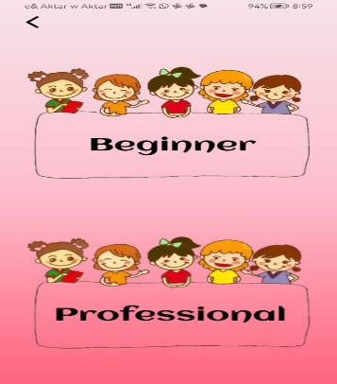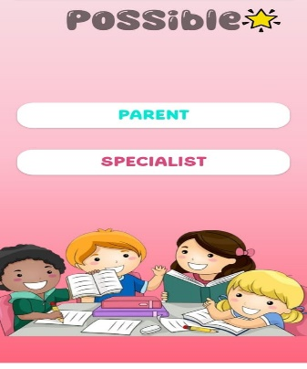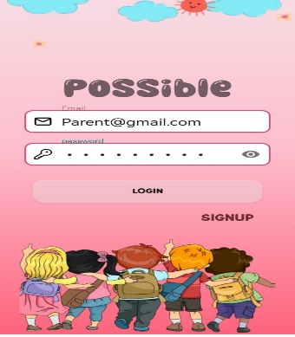6. Illustrative Examples

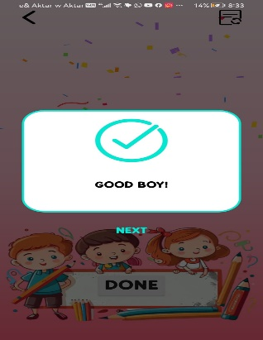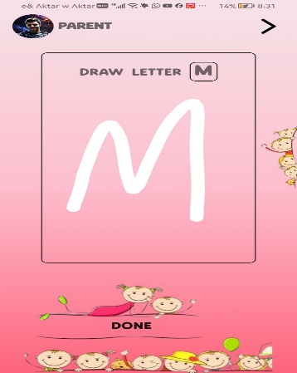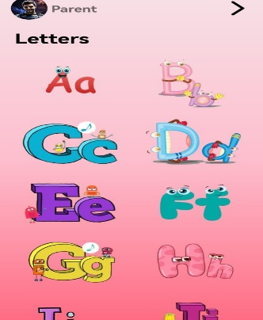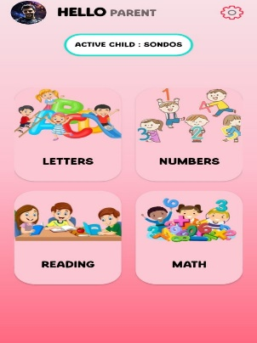

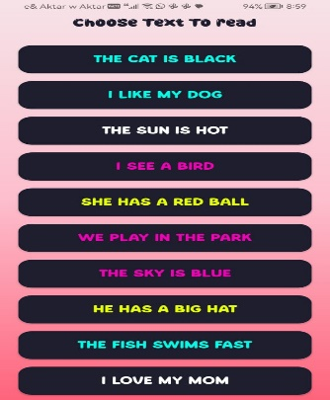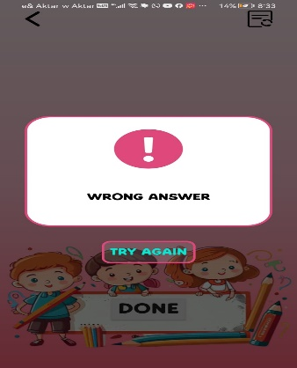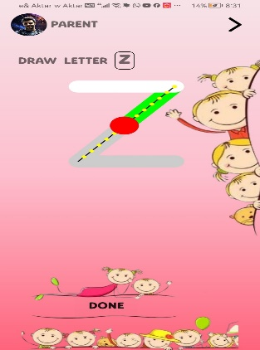

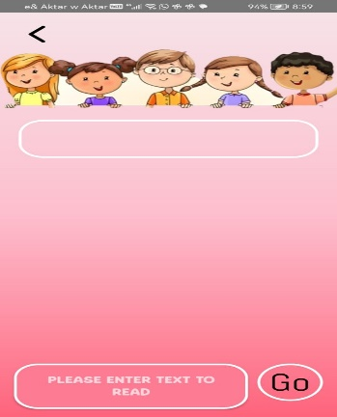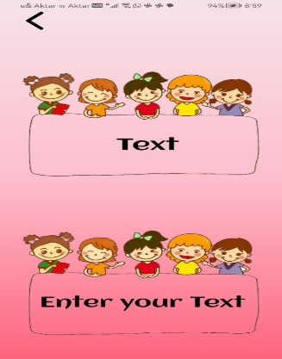

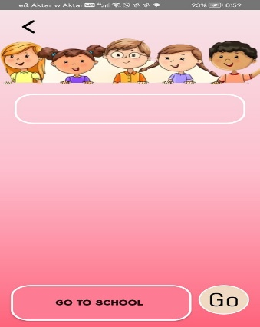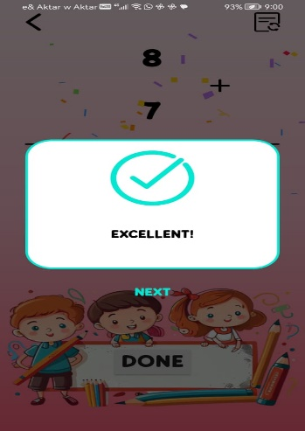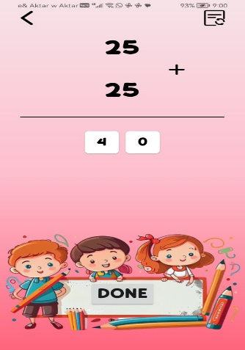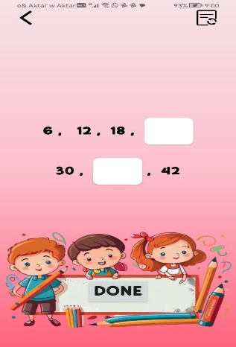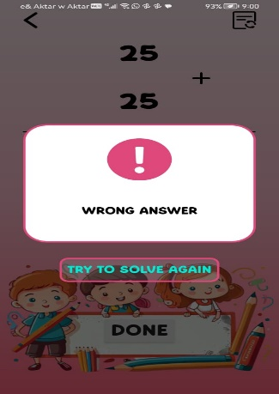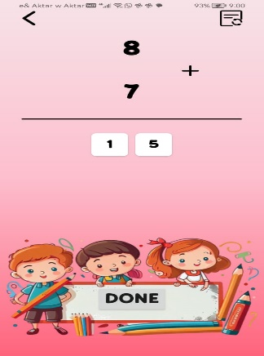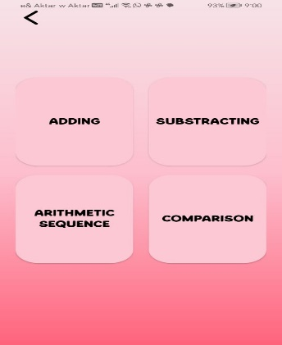

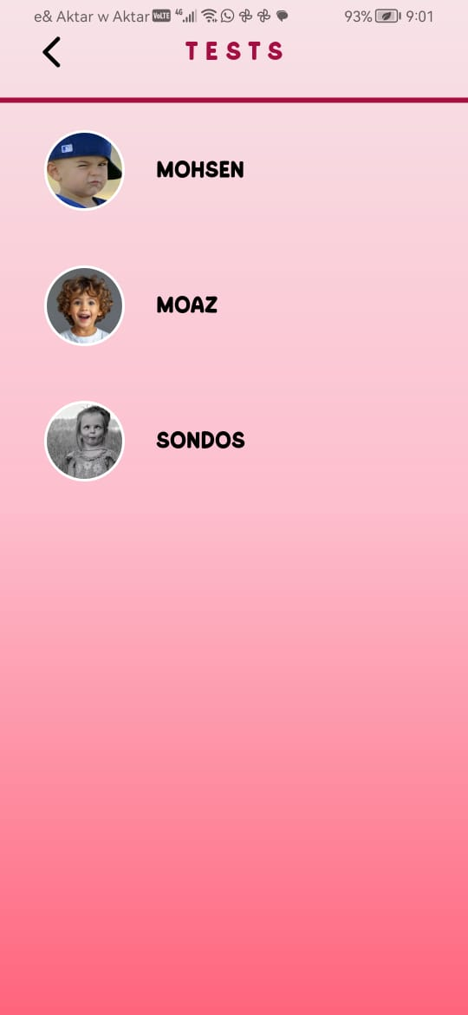

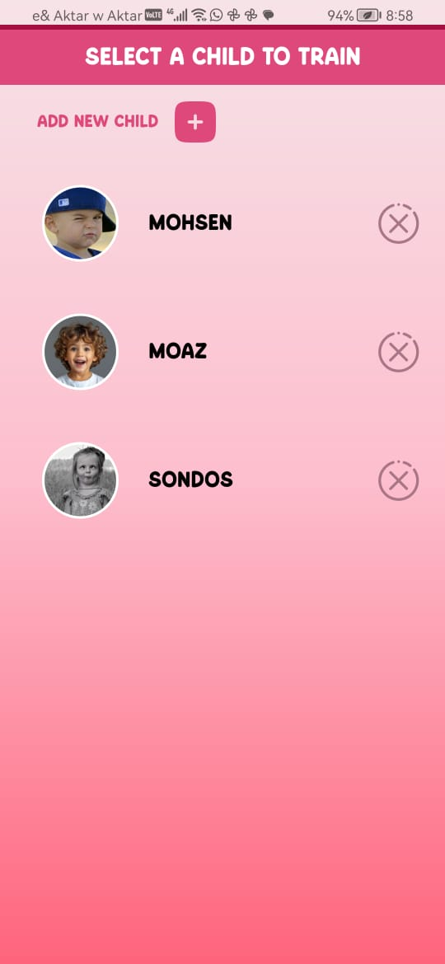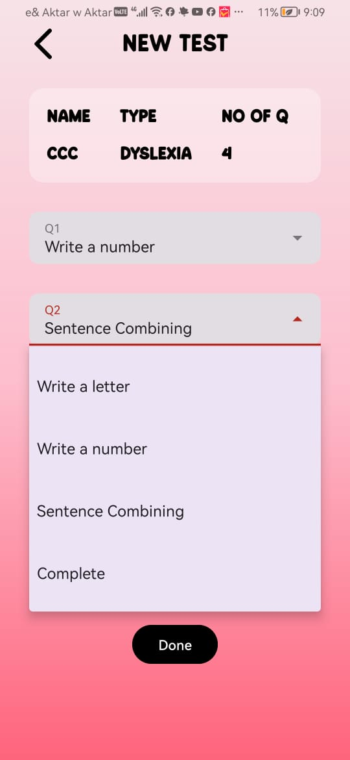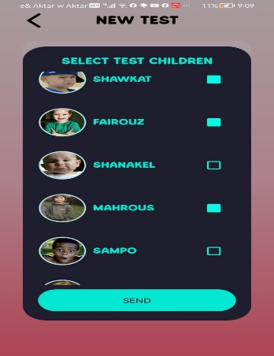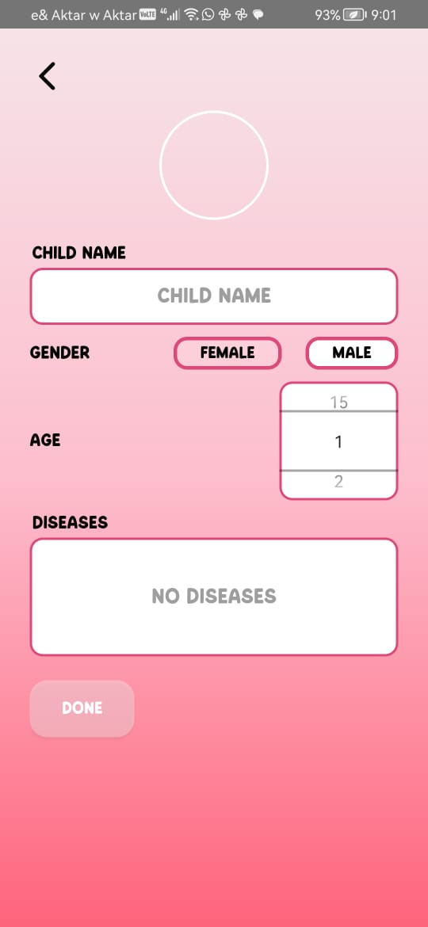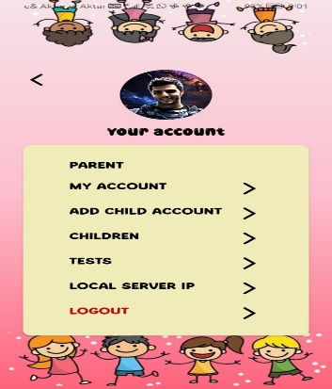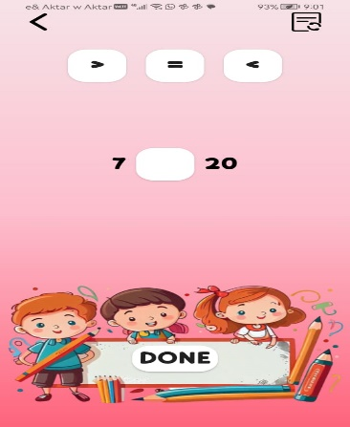

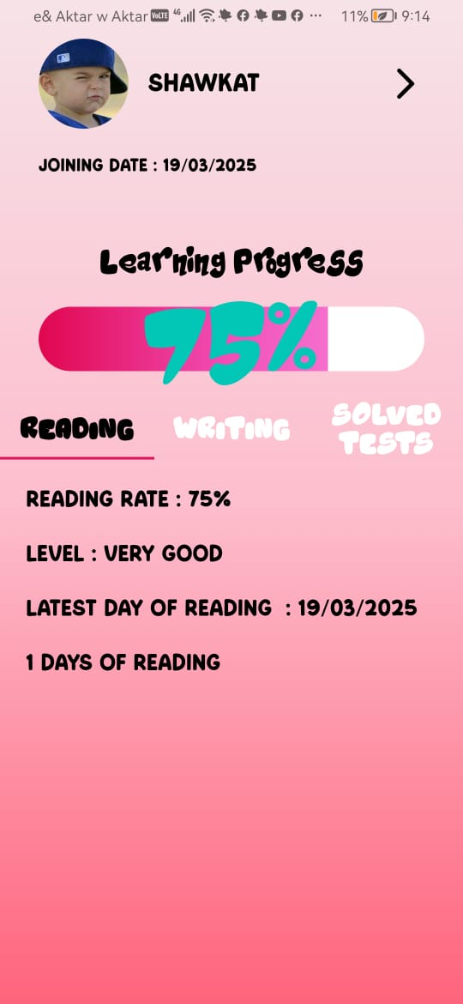

### **7.Impact of Our Application**

Target Audience and Use Case

Possible is designed for two primary user groups: parents and specialists. Parents can use the application to support their children’s learning at home, reducing the need for frequent specialist visits and providing structured exercises tailored to their child’s needs. Specialists, on the other hand, can utilize the platform to diagnose learning difficulties, create personalized assessments, and track student progress over time. By integrating both diagnosis and intervention, Possible offers a comprehensive tool for early detection and support of learning challenges in writing, reading, and math.

Innovative Aspects

What sets Possible apart is its AI-driven diagnostic and learning system. The application incorporates machine learning models to recognize handwriting, differentiate between children with and without learning difficulties, and adapt exercises accordingly. It also allows specialists to create and customize diagnostic tests, adjusting difficulty levels dynamically based on performance. Additionally, the integration of Google’s text-to-speech technology enhances reading exercises, making them more engaging and accessible for children.

Accessibility

Possible is designed to be widely accessible, with a user-friendly interface that allows parents and specialists to navigate easily. The application supports multiple child profiles, enabling families to track progress for more than one child. It is available on mobile devices, making it convenient for parents and specialists to use anywhere. Additionally, it includes educational resources such as videos and articles to help parents better understand learning difficulties and how to support their children effectively.

Reliability and Testing

To ensure high accuracy and reliability, Possible has undergone rigorous testing. The AI models used for handwriting recognition and difficulty assessment have achieved 99% accuracy in distinguishing correct and incorrect letter and number formations, as well as in identifying handwriting differences between children with and without learning difficulties. Google’s text-to-speech system has also been evaluated and proven effective in improving reading exercises, ensuring that children receive high-quality audio guidance.

New Research Question and Added Value

Possible contributes to the field of educational technology by introducing a data-driven approach to learning difficulty diagnosis and intervention. Traditional methods often rely on subjective evaluations, whereas this application provides quantifiable performance tracking. By analyzing real-time data on how children interact with exercises, the app generates valuable insights into their learning progress. This research-oriented approach has the potential to refine future intervention strategies and offer personalized learning pathways that adapt dynamically to each child’s needs.

Impact on Daily Practice and Commercialization

By reducing the dependency on frequent in-person specialist visits, Possible provides a cost-effective and time-saving alternative for families. It enables specialists to manage and assess multiple children efficiently, keeping a detailed history of their progress. Additionally, the platform’s potential for commercialization extends beyond individual users—it can be implemented in schools, therapy centers, and educational institutions to assist in large-scale diagnosis and intervention. The seamless combination of AI-powered assessments, personalized learning paths, and accessibility features makes Possible a scalable and impactful solution in the field of educational technology.

### 9. Future Directions

1. Expanding the Dataset

Initially, we faced challenges in collecting handwriting data from children with learning difficulties, especially in Arabic. In the future, we plan to collaborate with more speech and learning centers and schools to collect a broader and more diverse dataset, covering multiple languages to improve the accuracy and generalizability of our AI models.

2. Multi-Language Support

Currently, the application supports English only. A major future direction is the full integration of Arabic and other languages, enabling children to interact and learn in their native language, thereby enhancing engagement and understanding.

3. Gamification Features

To make the learning experience more engaging, we plan to implement motivational elements such as:

* A points and rewards system.
* Mini educational games within the app.
* A virtual assistant that provides encouragement and feedback.

4. Advanced Personalization Using AI

Although the app already adjusts to the child's level, we aim to introduce more advanced real-time analytics. This will allow the application to dynamically adjust the difficulty level of exercises based on the child's performance, creating a highly adaptive learning experience.

5. Integration with Educational Systems

We envision integrating the application into formal education systems, allowing it to be used in classrooms by teachers and specialists. This would include progress tracking tools and report sharing between educators and parents to ensure collaborative support.

6. Intelligent Real-Time Speech and Writing Assistance

Future updates will include features like:

* Real-time feedback on pronunciation during reading.
* Visual guidance and instant correction for writing tasks, making the learning experience more interactive and supportive.

7. AI-Powered Diagnosis and Intervention for Math Difficulties

In the next phase, we aim to enhance our mathematical learning section using AI models capable of:

* Diagnosing specific challenges in arithmetic skills (addition, subtraction, multiplication, division, sequences).
* Generating personalized math exercises targeting the child's weaknesses.
* Providing adaptive feedback based on real-time problem-solving behavior. This will allow the application to not only assess but also support children with dyscalculia or other math-related learning difficulties more effectively.

**8. Contribution to Longitudinal Research**

The anonymous data collected by the app can significantly contribute to long-term academic research. This includes refining diagnostic criteria, developing predictive models for early detection, and testing the effectiveness of various intervention strategies.

Ezquerro, L., Coimbra, R., Bauluz, B., Núñez-Lahuerta, C., Román-Berdiel, T., & Moreno-Azanza, M. (2024). Large dinosaur egg accumulations and their significance for understanding nesting behaviour. *Geoscience Frontiers*, *15*(5). https://doi.org/10.1016/j.gsf.2024.101872

Shahzad, M. F., Xu, S., Lim, W. M., Yang, X., & Khan, Q. R. (2024). Artificial intelligence and social media on academic performance and mental well-being: Student perceptions of positive impact in the age of smart learning. *Heliyon*, *10*(8). https://doi.org/10.1016/j.heliyon.2024.e29523